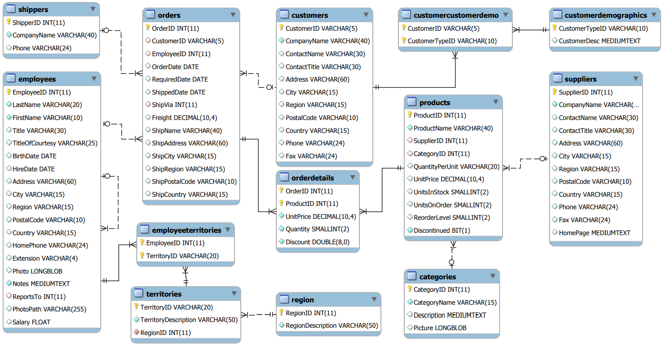

Consider the Northwind database whose schema is given in above Figure. This database contains information of orders placed by customers. For every order the detail is given of what products were sold, for what unit price and in what quantity. The employee that secured the order is recorded as well as the date in which the order was inserted. For customers the city they live in etc. is recorded, and for employees their sales district

1. What is the overall top ‘N’ selling food categories? The output must show the category name and the count of sales done by each category.

Sample Input 0: 3

Sample Output:

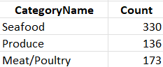

Sample Input 1: 6

Sample Output:

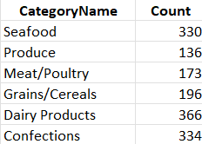

1. Write a query that produces a report of sales by month for all the top 3 categories (hint: get month and year with “month” and “year” functions). The report should display the Category name, country, year, month & count of sales done per category per country, per month per year.

Sample output:

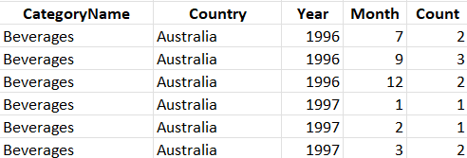

…….

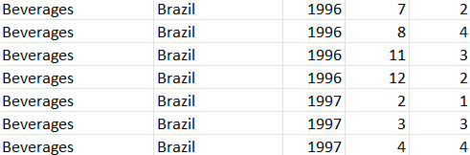

…….

Also, are there any countries and product categories for which the trend over time is increasing?

1. Display the ‘N’ Most Expensive Products from the available products along with the Unit Price of each Product.

Sample Input 0: 10

Sample Output 0:

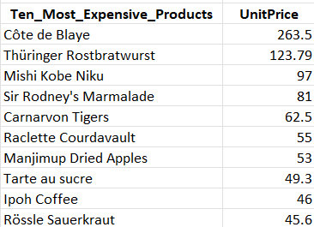

Sample Input 1: 4

Sample Output 1:

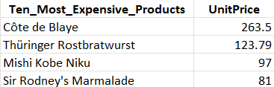

1. Write a query that shows the Company Name, Contact Title, City, Country of all customers in any city in Mexico or other cities in Spain other than the city of :

Sample Input 0: Madrid

Sample Output 0:

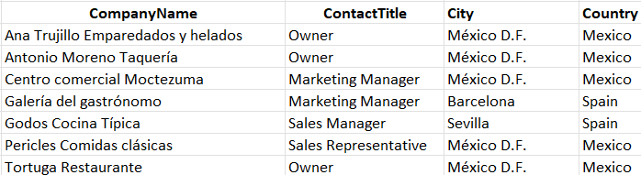

Sample Input 1: Barcelona

Sample Output 1:

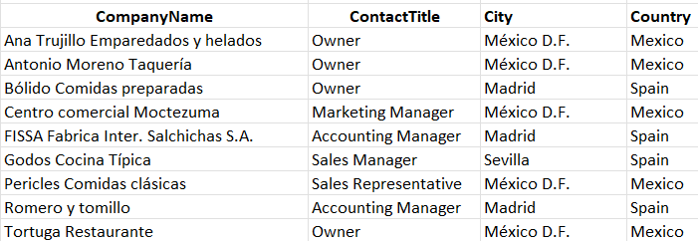

1. Create a SQL statement that gives the following output. (hint: you may use text functions)

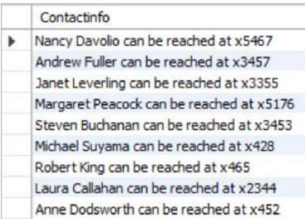

1. What are the Top 3 products purchased by customers in each country?
2. Create a dashboard with the following details from que 7-9:

Get the following KPIs:

1. Find the supplier share in sales for each category.
2. List total amount of sales in $ by employee and year (discount in OrderDetails is at UnitPrice level). Which employees have an increase in sales over the three reported years?
3. Display the order details showing the sales price for each order after discount is applied.
4. Display the Proportion of the number of orders placed for each category. Use a proper chart to show the proportion in %ages and highlight the category in the chart that shows the highest %age. (Hint: use explode option if applicable).
5. Do the following task:
6. Write a query that create a report that shows the Category_id, category_name, supplier_id, company_name, product_id, product_name from all products in category_id 6.
7. Create a report for the above same task in question 9(i) in Excel, but make the report dynamic such that user enters the category_id and according it shows category_name, supplier_id, company_name, product_id, product_name for that category id.